RMK ENGINEERING COLLEGE
DEPARTMENT OF CSM
SOFTWARE REQUIREMENTS SPECIFICATION
FOR
SEMINAR HALL BOOKING WEBSITE
Subject: Foundations of Full Stack
Subject Code: 26CS102
Submitted By
PRAGATI M
Register No.: 111726113029
Academic Year: 2026–2027

TABLE OF CONTENTS
1. Introduction
2. Overall Description
3. Functional Requirements
4. Non-Functional Requirements
5. External Interface Requirements
6. System Modules
7. Use Case Specifications
8. System Design Diagrams
9. Data Requirements
10. Technology Stack
11. Testing Requirements
12. Booking Rules and Workflow
13. Future Enhancements
14. Conclusion
15. Appendix

1. INTRODUCTION

1.1 Purpose
The Seminar Hall Booking Website is a web-based system designed to simplify and organize the process of reserving seminar halls within the institution. The system enables students to view hall details, check availability, submit booking requests, track booking status, and receive email notifications. The Head of the Department (HOD) acts as the approving authority.

1.2 Project Scope
The system provides a centralized interface for seminar hall reservation. It reduces manual coordination, avoids conflicting reservations, provides visibility of hall availability, and maintains booking information in an organized manner. The proposed system is designed as a responsive client-side web application using HTML5, CSS3, JavaScript ES6+, JSON data, and the Fetch API.

1.3 Problem Statement
In a manual seminar hall reservation process, students may need to contact faculty or department personnel to know whether a hall is available. Maintaining paper records or separate schedules can lead to delays, duplicate requests, and difficulty tracking booking status. The proposed website provides a structured digital workflow from availability checking to HOD approval and notification.

1.4 Objectives
• Provide an easy-to-use seminar hall booking interface.
• Display hall capacity, facilities and availability.
• Prevent overlapping bookings for the same hall and time slot.
• Allow students to submit and track booking requests.
• Provide HOD-based approval or rejection.
• Send email notifications for important booking status changes.
• Provide a responsive interface suitable for desktop, tablet and mobile screens.

1.5 Intended Users
Primary user: Student. The HOD is the approving authority for booking requests. Administrative functions may be represented as a future extension if required.

1.6 Definitions and Abbreviations
Term | Meaning
SRS | Software Requirements Specification
HOD | Head of the Department
UI | User Interface
API | Application Programming Interface
JSON | JavaScript Object Notation
DOM | Document Object Model
ES6+ | ECMAScript 6 and later JavaScript features

2. OVERALL DESCRIPTION

2.1 Product Perspective
The Seminar Hall Booking Website acts as a centralized front-end application for managing hall availability and booking requests. The application presents data through responsive web pages and uses JavaScript to validate forms, manipulate the DOM, retrieve JSON data through the Fetch API, and update booking status dynamically.

2.2 Major Product Functions
• Student login/authentication interface
• Hall listing and detailed hall information
• Date and time availability checking
• Booking request submission
• Booking conflict validation
• Booking status tracking
• Cancellation request where permitted
• HOD approval/rejection workflow
• Email notification trigger/integration concept
• Booking history and summary

2.3 User Characteristics
User | Responsibilities
Student | Login, browse halls, check availability, submit booking request, view status/history, cancel eligible requests.
HOD | Review booking requests, approve/reject requests, view schedules and manage departmental booking decisions.

2.4 Operating Environment
The system is intended to operate in modern web browsers such as Google Chrome, Microsoft Edge, Mozilla Firefox and equivalent browsers. It should work on Windows and other operating systems that support modern browsers.

2.5 Constraints
• The interface should use the technologies covered by the course.
• Booking information must be validated before submission.
• A hall must not be confirmed for overlapping time slots.
• Email notification depends on an appropriate email service or backend integration in a full implementation.
• The prototype may use JSON data as the client-side data source.

2.6 Assumptions and Dependencies
The institution provides valid hall information and booking rules. Users provide correct booking details. The HOD is available to review requests. Email delivery requires a configured notification service in a production implementation.

3. FUNCTIONAL REQUIREMENTS
ID | Requirement | Description
FR-01 | User Authentication | The system shall allow a student to enter valid login credentials and access the booking interface.
FR-02 | View Halls | The system shall display available seminar halls with capacity, location and facilities.
FR-03 | Search/Filter | The system shall allow users to filter halls based on suitable date, time, capacity or facilities.
FR-04 | Availability Check | The system shall show whether a hall is available for a selected date and time.
FR-05 | Booking Request | The system shall allow a student to submit a booking request with event purpose, date, start time, end time and required hall.
FR-06 | Validation | The system shall validate mandatory fields and reject invalid or incomplete booking details.
FR-07 | Conflict Prevention | The system shall prevent confirmation of overlapping bookings for the same hall.
FR-08 | Booking Status | The system shall display Pending, Approved, Rejected or Cancelled status.
FR-09 | HOD Approval | The HOD shall be able to review, approve or reject pending booking requests.
FR-10 | Cancellation | The system shall allow eligible booking requests to be cancelled according to the defined rules.
FR-11 | Booking History | The student shall be able to view previous and current booking requests.
FR-12 | Notifications | The system shall support email notifications for booking submission and status changes.
FR-13 | Schedule View | The system shall provide a consolidated view of hall bookings and free slots.
FR-14 | Responsive UI | The website shall adapt its layout to desktop, tablet and mobile screen sizes.

4. NON-FUNCTIONAL REQUIREMENTS
Quality Attribute | Requirement
Performance | Pages should load quickly under normal campus network conditions and user actions should receive prompt feedback.
Usability | The interface should be simple, readable and easy for first-time users.
Accessibility | Semantic HTML, readable text, keyboard-friendly controls, labels and appropriate contrast should be used.
Security | Authentication data and booking information should be protected; user input should be validated.
Reliability | The system should maintain consistent booking status and avoid duplicate confirmed slots.
Availability | The application should be accessible during normal institutional working periods.
Maintainability | HTML, CSS and JavaScript should be modular and clearly organized.
Scalability | The design should permit additional halls, users and departments to be added.
Compatibility | The website should support current versions of major browsers.
Responsiveness | The UI should remain usable across different screen sizes.

5. EXTERNAL INTERFACE REQUIREMENTS

5.1 User Interface
Screen | Main Contents
Login Page | Username/email, password, login button, validation message.
Home/Dashboard | Navigation, hall summary, current bookings and quick actions.
Hall Listing | Hall cards/table, capacity, location, facilities, availability.
Hall Details | Detailed information and booking action.
Booking Form | Hall, date, start time, end time, event title/purpose, participant count.
My Bookings | Pending, approved, rejected and cancelled requests.
HOD Approval Page | Pending requests, request details, approve/reject actions.
Notification Area | Booking and approval status messages.

5.2 Software Interfaces
The prototype uses HTML5 for semantic structure, CSS3 for presentation and responsive layout, JavaScript ES6+ for interaction and DOM manipulation, JSON for structured data, and the Fetch API for retrieving data.

5.3 Communication Interface
The client-side application may communicate with a web/API layer using HTTP/HTTPS. Email notification is treated as an external service integration for a complete deployment.

6. SYSTEM MODULES

6.1 Student Management
Handles login, student profile details and access to booking functions.

6.2 Hall Management
Stores and displays hall name, capacity, location, facilities and availability information.

6.3 Availability Management
Checks selected date/time against existing bookings and identifies free slots.

6.4 Booking Management
Creates booking requests, validates details, assigns a status and maintains booking history.

6.5 HOD Approval Management
Presents pending requests to the HOD and records approval or rejection decisions.

6.6 Notification Management
Generates email notification events for booking submission and status changes.

6.7 Schedule Management
Displays confirmed reservations and available time slots in an organized schedule.

7. USE CASE SPECIFICATIONS
Use Case | Actor | Precondition | Main Outcome
Login | Student | User has valid credentials. | Student dashboard is displayed.
View Halls | Student | User is logged in. | Hall list and details are displayed.
Check Availability | Student | Hall and date/time are selected. | Availability result is displayed.
Submit Booking | Student | Selected slot is available and form is valid. | Request is stored as Pending.
View Booking Status | Student | Booking exists. | Current status is displayed.
Cancel Booking | Student | Booking is eligible for cancellation. | Booking status becomes Cancelled.
Review Request | HOD | Pending request exists. | Request details are displayed.
Approve Booking | HOD | Request satisfies rules and slot is free. | Status becomes Approved.
Reject Booking | HOD | Request is unsuitable or invalid. | Status becomes Rejected with reason.
Receive Notification | Student | Booking event occurs. | Email notification is generated.

7.1 Use Case Diagram
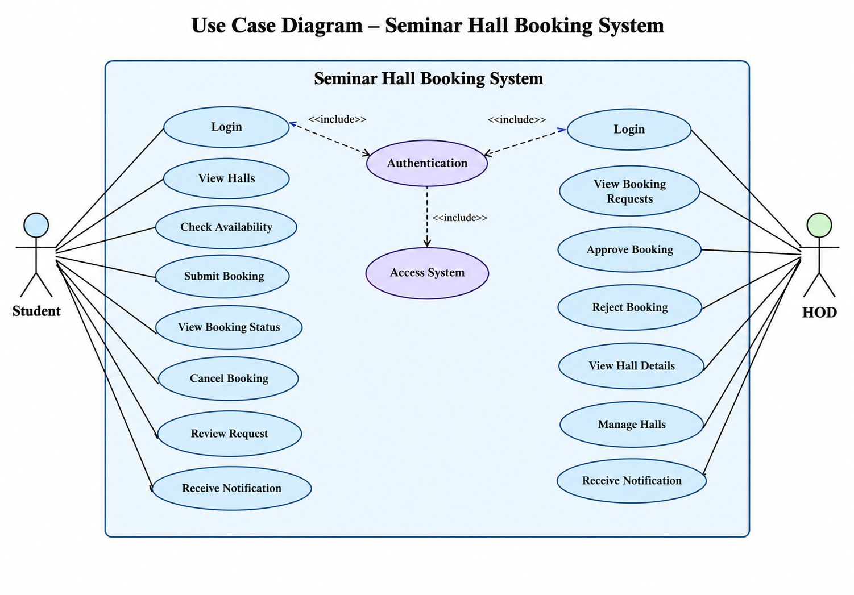

8. SYSTEM DESIGN DIAGRAMS

8.1 System Architecture
Layer | Components
Presentation Layer | HTML5 pages, CSS3 responsive layout, forms and navigation
Client Logic Layer | JavaScript ES6+, DOM manipulation, validation, event handling
Data Layer | JSON data / API responses, Fetch API
Approval Layer | HOD review and booking status management
Notification Layer | Email notification service/integration
Architecture Flow: Student Browser → HTML/CSS UI → JavaScript → Fetch API → JSON/API Data → Booking/Approval Logic → Email Notification

8.2 Context / DFD Level 0
External Entity | Data Flow | System
Student | Login details, hall search, booking request, cancellation | Seminar Hall Booking Website
HOD | Review decision, approval/rejection | Seminar Hall Booking Website
Email Service | Notification request / delivery status | Seminar Hall Booking Website

8.3 DFD Level 1 – Major Processes
Process | Input | Output
P1 User Authentication | Credentials | Authenticated session/access
P2 Hall & Availability | Date, time, filters | Available hall information
P3 Booking Management | Booking form | Pending/updated booking
P4 HOD Approval | Booking request, decision | Approved/Rejected status
P5 Notification | Booking status event | Email notification

8.4 Activity Flow
Start → Student Login → View Halls → Select Hall → Select Date/Time → Check Availability → [Available?] → Complete Booking Form → Submit Request → HOD Review → [Approve?] → Approved → Email Notification → End. If unavailable, select another slot. If rejected, display rejection status and allow a new request.

8.5 ER Diagram – Entities
Entity | Key Attributes
STUDENT | Student_ID, Name, Email, Department, Phone
HALL | Hall_ID, Hall_Name, Capacity, Location, Facilities, Status
BOOKING | Booking_ID, Student_ID, Hall_ID, Date, Start_Time, End_Time, Purpose, Status
HOD | HOD_ID, Name, Department, Email
NOTIFICATION | Notification_ID, Booking_ID, Recipient_Email, Type, Sent_Date, Status

8.6 Class Diagram – Main Classes
Class | Important Attributes / Methods
Student | studentId, name, email | login(), viewHalls(), bookHall(), cancelBooking(), viewStatus()
Hall | hallId, name, capacity, location, facilities | checkAvailability()
Booking | bookingId, date, startTime, endTime, purpose, status | validate(), submit(), cancel()
HOD | hodId, name, email | reviewRequest(), approve(), reject()
Notification | notificationId, email, type, status | sendEmail()

8.7 Sequence Diagram – Booking
Student → Website: Login → Website → Student: Dashboard → Student → Website: Select hall/date/time → Website → Data/API: Check availability → Data/API → Website: Available → Student → Website: Submit request → Website → Booking Data: Store Pending → Website → HOD: Notify pending request → HOD → Website: Approve/Reject → Website → Notification Service: Send email → Notification Service → Student: Booking status email.

8.8 Git/GitHub Workflow
Local Repository → Feature Branch → Code Changes → Commit → Push to GitHub → Pull Request → Review → Merge to Main. Recommended branches: main, feature/login, feature/hall-list, feature/booking, feature/hod-approval, feature/notifications.

9. DATA REQUIREMENTS

9.1 Student Data
Field | Type | Description
Student_ID | String | Unique student identifier
Name | String | Student name
Email | String | Institutional email
Department | String | Academic department
Phone | String | Contact number

9.2 Hall Data
Field | Type | Description
Hall_ID | String | Unique hall identifier
Hall_Name | String | Name of seminar hall
Capacity | Integer | Maximum permitted participants
Location | String | Hall location
Facilities | Array/String | Projector, audio, seating, AC etc.
Status | String | Available / Maintenance

9.3 Booking Data
Field | Type | Description
Booking_ID | String | Unique booking identifier
Student_ID | String | Requesting student
Hall_ID | String | Selected hall
Date | Date | Event date
Start_Time | Time | Event start
End_Time | Time | Event end
Purpose | String | Reason/event description
Status | String | Pending / Approved / Rejected / Cancelled

10. TECHNOLOGY STACK
Technology | Purpose
HTML5 | Semantic page structure and accessible forms
CSS3 | Styling, layout and responsive design
JavaScript ES6+ | Interactivity, validation, DOM and event handling
JSON | Structured client-side/API data
Fetch API | Asynchronous retrieval of JSON/API data
Git | Version control
GitHub | Repository hosting and collaboration
Modern Web Browser | Execution environment

10.1 Suggested Project Structure
seminar-hall-booking/
├── index.html
├── pages/
│ ├── login.html
│ ├── halls.html
│ ├── booking.html
│ ├── my-bookings.html
│ └── hod-dashboard.html
├── css/
│ └── style.css
├── js/
│ ├── app.js
│ ├── auth.js
│ ├── halls.js
│ ├── booking.js
│ └── hod.js
├── data/
│ ├── halls.json
│ └── bookings.json
└── assets/

11. TESTING REQUIREMENTS
TC ID | Test Scenario | Expected Result
TC-01 | Login with valid details | User enters the system successfully.
TC-02 | Login with invalid details | Validation/error message is displayed.
TC-03 | View hall list | Available halls and details are displayed.
TC-04 | Search unavailable slot | System indicates that the selected slot is unavailable.
TC-05 | Submit valid booking | Booking is stored with Pending status.
TC-06 | Submit incomplete booking form | Required field validation prevents submission.
TC-07 | HOD approves request | Booking becomes Approved and notification is generated.
TC-08 | HOD rejects request | Booking becomes Rejected and notification is generated.
TC-09 | Cancel eligible booking | Booking becomes Cancelled.
TC-10 | Responsive layout | Pages remain usable on desktop, tablet and mobile widths.
TC-11 | Duplicate slot request | System prevents conflicting confirmation.
TC-12 | Email notification event | Correct recipient and booking status are included.

11.1 Testing Types
• Functional Testing
• Integration Testing
• User Interface Testing
• Usability Testing
• Responsive Testing
• Validation and Error Handling Testing
• Cross-Browser Testing

12. BOOKING RULES AND WORKFLOW

12.1 Proposed Booking Rules
• Only authenticated students can submit booking requests.
• A student must provide event purpose, date, start time, end time and expected participant count.
• The requested participant count must not exceed hall capacity.
• Overlapping bookings for the same hall are not permitted.
• A request remains Pending until reviewed by the HOD.
• Only the HOD can approve or reject a pending request.
• An approved booking reserves the selected hall and time slot.
• A student may cancel an eligible request before the event according to departmental policy.
• Email notifications are generated for submission, approval, rejection and cancellation events.
• Bookings for halls marked under maintenance cannot be submitted.

12.2 Booking Workflow
Student Login → Browse Halls → Check Availability → Enter Booking Details → Submit Request → Pending → HOD Review → Approve / Reject → Update Status → Send Email Notification → Student Views Status.

13. FUTURE ENHANCEMENTS
• Online calendar integration
• QR-code based booking confirmation
• Automated reminder emails
• Mobile application
• Real-time notification system
• Multiple department support
• Analytics and booking utilization reports
• Integration with institutional authentication

14. CONCLUSION
The Seminar Hall Booking Website provides a structured and user-friendly approach to seminar hall reservation. It enables students to discover suitable halls, check availability, submit booking requests and track status, while allowing the HOD to control approval decisions. The proposed technologies align with the learning outcomes of Foundations of Full Stack by applying semantic HTML5, responsive CSS3, modern JavaScript, DOM manipulation, Fetch API, JSON and Git/GitHub practices.

15. APPENDIX

15.1 Sample JSON – Hall
{ "hallId": "H001", "hallName": "Main Seminar Hall", "capacity": 300, "location": "Academic Block", "facilities": ["Projector", "Audio System", "Air Conditioning"], "status": "Available" }

15.2 Sample JSON – Booking
{ "bookingId": "B001", "studentId": "111726113029", "hallId": "H001", "date": "2026-10-20", "startTime": "10:00", "endTime": "12:00", "purpose": "Department Seminar", "status": "Pending" }

15.3 References
1. Course syllabus: Foundations of Full Stack, Subject Code 26CS102.
2. HTML5, CSS3 and JavaScript learning materials provided for the course.
3. Git and GitHub documentation and course learning resources.

